Tp PS

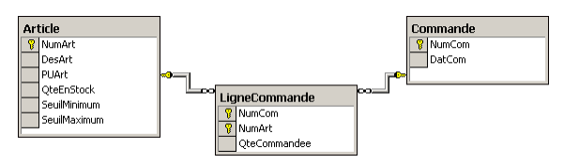

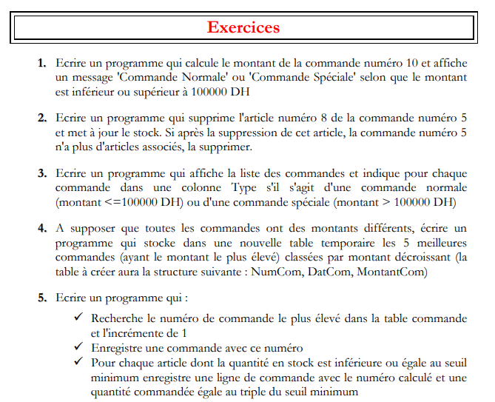

|  |
| --- |
| delimiter $$  CREATE procedure q1(cc int)  begin  declare total int;  select sum(a.PU * lc.QteCommandee) into total  from article a, lignecmd lc  where a.codeArt=lc.codeArt and lc.codeCmd=cc;  if total <1000 THEN  select concat('codeCmd : ', cc ,' -Total : ' ,total,' - remarque : Commande normal');  ELSE  select concat('codeCmd : ' ,cc,' -Total : ' ,total,' - remarque : Commande Spécial');  end if;  end$$  call q1(10) ;$$ |
| Dans le processus de l’achat  Lors de l’achat de 100 unité de l’article 8, on incrémente le stock par 100  Lorsqu’on annule l’achat on décrémente le stock |
| delimiter $$  CREATE procedure q2_AnnulerAchat(cc int, ca int)  begin  DECLARE qt int;  declare nbr int;  select lc.QteCommandee into qt from lignecmd lc  where lc.codeCmd=cc and lc.codeArt=ca;  update article set QteEnStock =QteEnStock -qt;  DELETE from lignecmd where codeCmd=cc and codeArt=ca;  select count(*) into nbr from lignecmd where codeCmd=cc;  if nbr=0 THEN  delete from commande where codeCmd=cc;  select concat('La commande : ' ,cc ,' ne contient plus d''article,elle sera supprimée') as 'remarque1';  ELSE  select concat('La commande : ' ,cc ,' contient encore : ',nbr, ' articles') as 'remarque2';  end if;  end$$  call q2_AnnulerAchat(89,1 ) |
| delimiter $$  drop procedure q2_AnnulerAchat;$$  CREATE procedure q2_AnnulerAchat(cc int, ca int)  begin  DECLARE qt int;  declare nbr int;  declare nbrCmd int;  select count(*) into nbrCmd from commande where codeCmd=cc;  if nbrCmd>0 then  begin  select lc.QteCommandee into qt from lignecmd lc  where lc.codeCmd=cc and lc.codeArt=ca;  update article set QteEnStock =QteEnStock -qt where codeArt=ca;  DELETE from lignecmd where codeCmd=cc and codeArt=ca;  select count(*) into nbr from lignecmd where codeCmd=cc;  if nbr=0 THEN  delete from commande where codeCmd=cc;  select concat('La commande : ' ,cc ,' ne contient plus d''article,elle sera supprimée') as 'remarque1';  ELSE  select concat('La commande : ' ,cc ,' contient encore : ',nbr, ' articles') as 'remarque2';  end if;  end;  ELSE  SELECT concat('la commnde : ', cc, ' n''existe pas') as 'remarque';  end if;  end$$ |
| delimiter $$  CREATE PROCEDURE Q3()  begin  select c.dateCmd, c.codeCmd,sum( a.PU*lc.QteCommandee) as 'Montant',  CASE  when sum( a.PU*lc.QteCommandee)<10000 then 'Commande normale'  ELSE  'Commande spéciale'  end as 'remarque'  from commande c,lignecmd lc, article a  where a.codeArt=lc.codeArt and c.codeCmd=lc.codeCmd  group by c.dateCmd, c.codeCmd  order by sum( a.PU*lc.QteCommandee);  end$$ |
| create temporary TABLE MaxCmd as  select c.dateCmd, c.codeCmd,sum( a.PU*lc.QteCommandee) as 'Montant'  from commande c,lignecmd lc, article a  where a.codeArt=lc.codeArt and c.codeCmd=lc.codeCmd  group by c.dateCmd, c.codeCmd  order by sum( a.PU*lc.QteCommandee) desc  limit 5; |
| create temporary TABLE test(codetest int , nomtest varchar(20));  [insert](http://127.0.0.1:84/phpmyadmin/url.php?url=https://dev.mysql.com/doc/refman/8.0/en/insert.html) into test [values](http://127.0.0.1:84/phpmyadmin/url.php?url=https://dev.mysql.com/doc/refman/8.0/en/miscellaneous-functions.html%23function_values)(10,'azerty'),(20,'wwww'),(30,'mlkjh');  [select](http://127.0.0.1:84/phpmyadmin/url.php?url=https://dev.mysql.com/doc/refman/8.0/en/select.html) * from test; |
| Delimiter $$  Create procedure Q5()  Begin  declare CodeMax int;  declare dt date;  select CURRENT_DATE into dt;  select max(codeCmd) into codeMax from commande;  set codeMax=codemax+1;  insert into commande values(codeMax, dt);  insert into lignecmd select codeMax ,a.codeArt ,a.SeuilMin*3 from article a  where a.QteEnStock <a.SeuilMin;  End$$ |